MINURI

Iteration 1 - Data Management Plan

Topic: Shielding Crisis & Community Resilience
SDG 3: Good Health and Wellbeing | SDG 11: Sustainable Cities and Communities
Scope: Melbourne, Victoria

1. Purpose and scope
This Data Management Plan is a live document describing how Minuri uses and governs data in Iteration 1. It covers the three data sources in use, the pipeline that moves data from source to API, update cadence, storage and retention rules, and the ethical, legal, and privacy considerations that shape these decisions. Iteration 1 is deliberately read-only and privacy-light: no login, no personally identifiable information collected, no server-side user state. Bookmarks live in the user's own browser via localStorage.

2. Data sources
Minuri uses three external data sources. Two are loaded once per iteration into PostgreSQL (hosted on Neon) by dedicated import scripts; the third is called live at request time and is not persisted.
Source | Access | What it gives us | Source update frequency | System update frequency
Australian Postcodes (GitHub) | CSV (public GitHub raw URL)  https://github.com/matthewproctor/australianpostcodes | Suburb master data for Greater Melbourne: locality, postcode, state, lat/lng, SA2 code, SA3 name | Community-maintained; irregular | Loaded once per iteration via script
ABS Regional Population (Table 2) | XLSX download from abs.gov.au  https://www.abs.gov.au/statistics/people/population/regional-population/latest-release | ERP population values (2024, 2025) and growth / density by SA2, SA3, SA4, GCCSA — powers the suburb demographic snapshot | Annual (release 2024-25 is current) | Extracted then loaded once per iteration
SerpApi - Google Local results | Live REST API  https://serpapi.com/search-api | Nearby place results for Near Me: names, ratings, addresses, listing metadata | Continuous (reflects Google's index) | Request-time only — not persisted

2.1 Australian Postcodes, suburb master data
A community-maintained postcode and locality CSV for Australia, used as our source of truth for suburb names and coordinates. The loader load_melbourne_suburbs filters the CSV to Greater Melbourne (SA4 206–214, Victoria) and writes it to the suburbs table. Read at runtime by GET /suburb and GET /suburb/larger-region to power the autocomplete and SA3 grouping. Attribution to the upstream maintainer is preserved; the dataset is not redistributed outside the application.

2.2 ABS Regional Population, demographic context
ABS Regional Population (2024-25 release, Table 2) provides Estimated Resident Population by SA2, SA3, SA4, and GCCSA for all Victorian statistical areas. A two-step offline pipeline (extract → load_population_records) converts the XLSX to CSV and loads it into the suburb_demographics table; GET /api/population aggregates erp_2025 against the requested location. Suburb names do not always map cleanly to SA2 — where the match is ambiguous, the UI hides the snapshot rather than fabricate a figure. Released under CC BY 4.0 with attribution to the ABS.

2.3 SerpApi, live place data
A paid, key-authenticated third-party API returning structured Google Local results. app.services.near_me builds a query from the active topic and suburb, calls SerpApi over HTTPS using the server-side SERPAPI_API_KEY, and normalises the response before returning it from GET /api/nearby-interest. Results are not persisted - they live only for the lifetime of the response. The API key is loaded from a .env file excluded from version control, never logged, and never sent to the browser. Usage follows SerpApi's terms of service; results are surfaced for real-time browsing only.

3. Data pipeline
Described in two parts: the offline load that runs once per iteration, and the runtime flow for a single Near Me request. Three principles shape the design — external keys never reach the browser, the frontend speaks to one backend schema regardless of source, and no personal data is stored server-side.

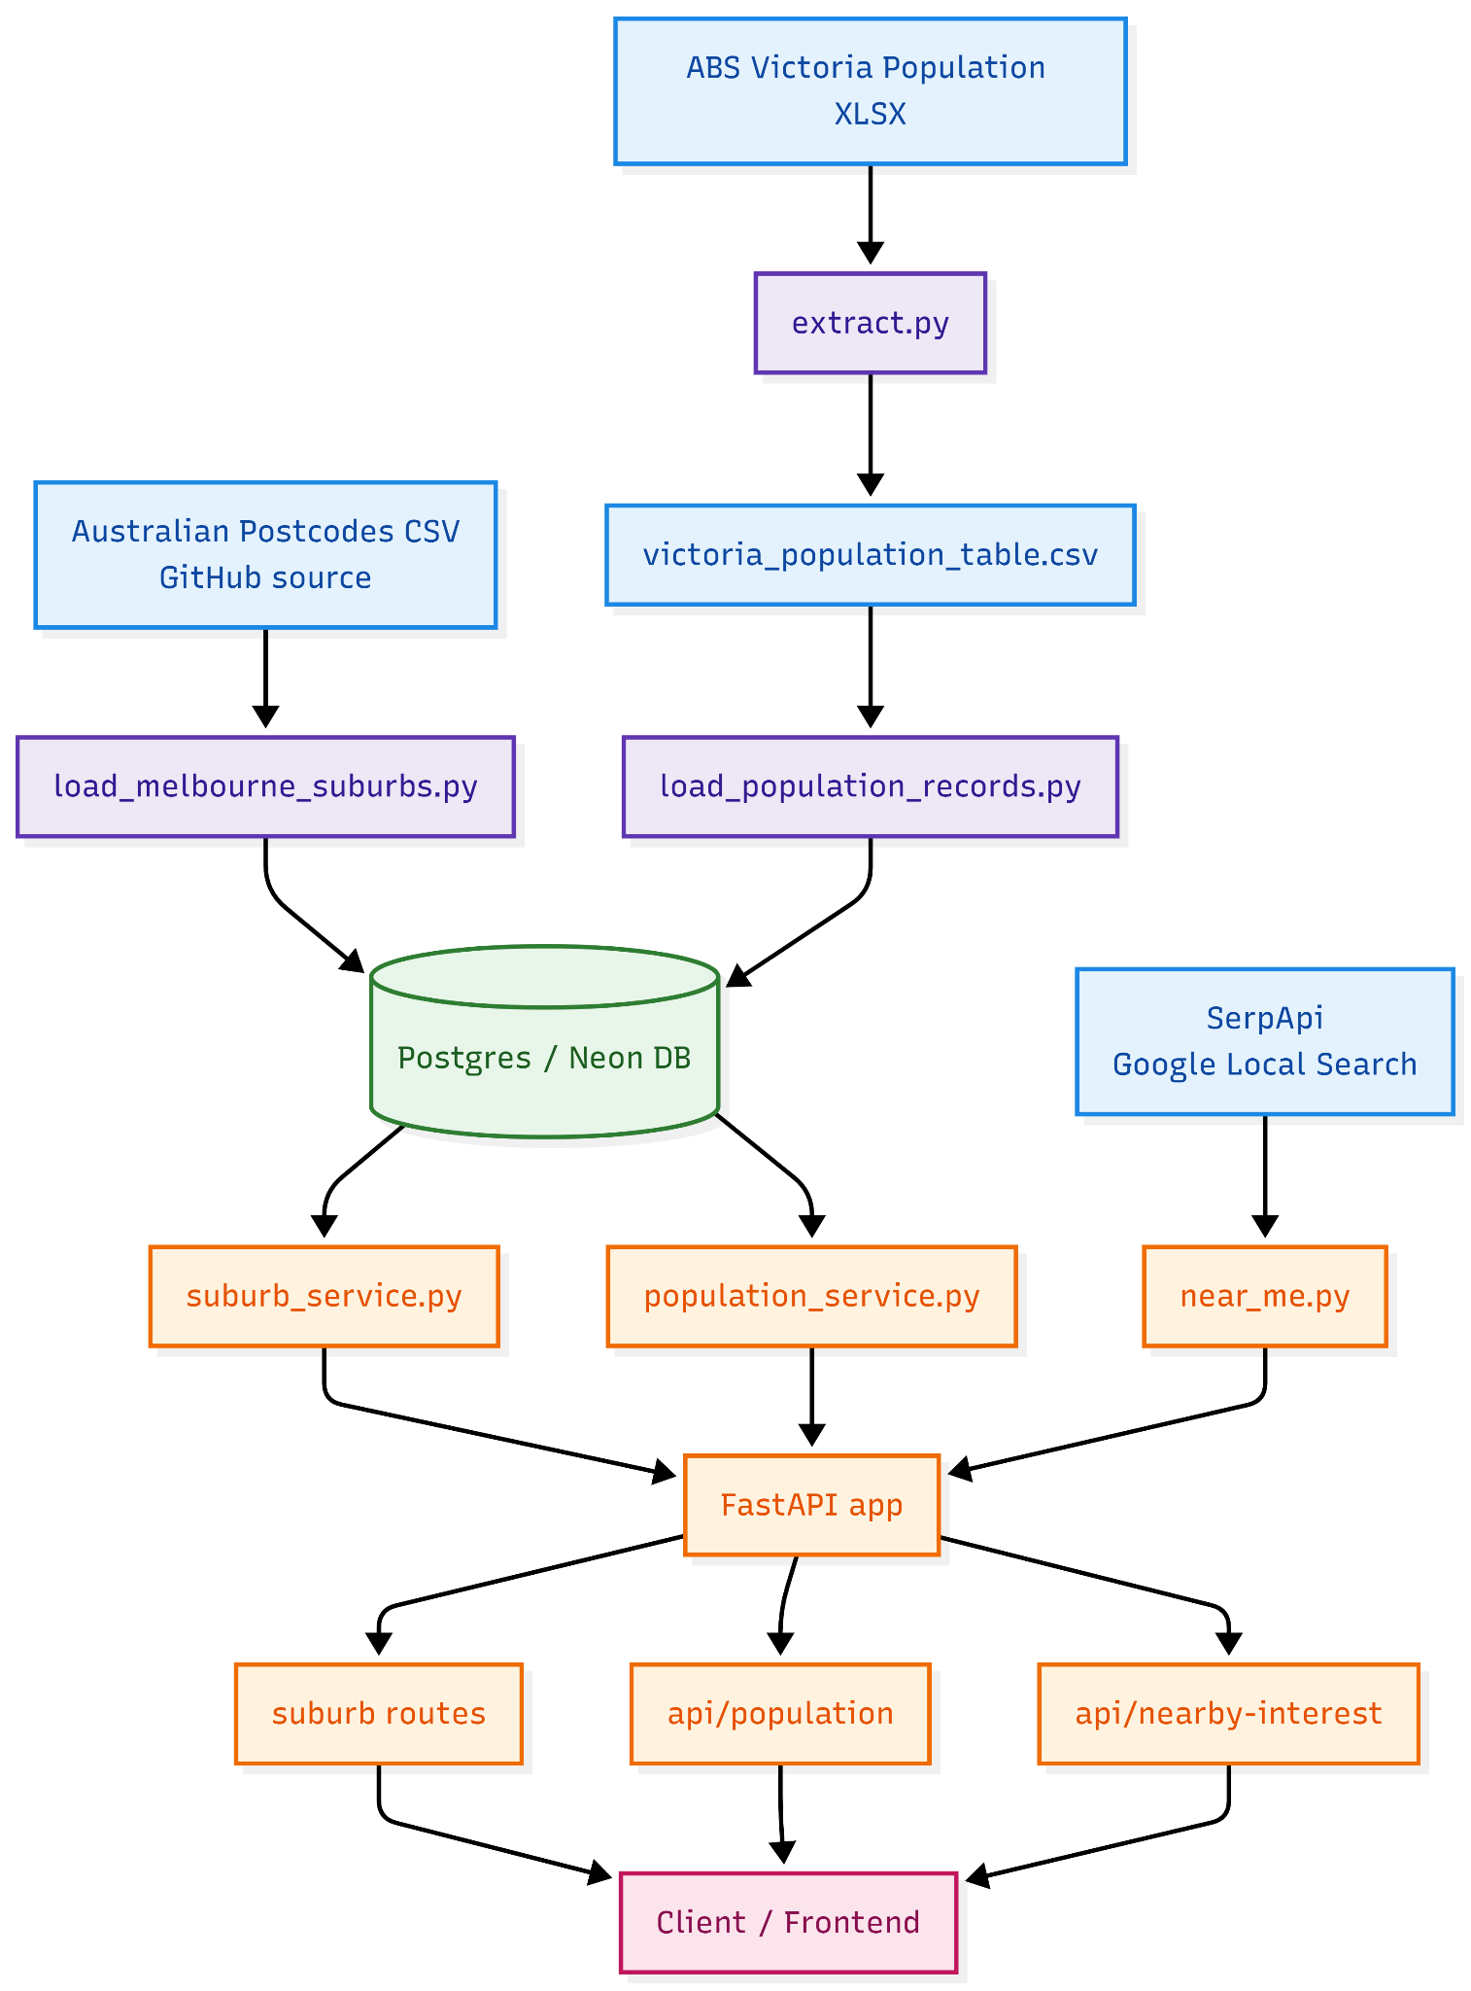

3.1 Offline load (per iteration)
- Load suburbs: uv run python -m app.scripts.load_melbourne_suburbs - fetches the CSV, filters to Greater Melbourne, writes to suburbs.
- Extract population: uv run python -m app.scripts.extract - converts the ABS XLSX into victoria_population_table.csv.
- Load population: uv run python -m app.scripts.load_population_records - writes the CSV into suburb_demographics.
- Sanity check: start the server and confirm endpoint shapes at /docs. All load scripts are idempotent - safe to re-run when a new release lands.

3.2 Runtime flow
# | Layer | What happens | Why it is designed this way
1 | Browser (frontend) | The user selects a suburb (or opts in to geolocation, which resolves to a suburb). The frontend issues a request to the Minuri backend — never directly to SerpApi or any external service. | Keeps the SerpApi key off the client and creates a single chokepoint for input validation, future caching, and consistent error shape.
2 | FastAPI router | Requests route to one of three endpoints:  • /suburb — autocomplete and larger-region lookup  • /api/population — demographic context  • /api/nearby-interest — live places | Splitting by responsibility keeps each endpoint small, lets each service fail independently, and stops the snapshot line from blocking the place results.
3a | suburb_service → Postgres (Neon) | Reads the suburbs table populated by load_melbourne_suburbs. Returns locality, postcode, state, coordinates, and SA3 grouping. | Static pre-loaded data means fast lookups and no external dependency at request time.
3b | population_service → Postgres (Neon) | Reads suburb_demographics. Matches location name against SA2, SA3, SA4, or GCCSA and aggregates erp_2025. | One endpoint answering multiple geographic levels keeps the frontend simple and lets the UI degrade gracefully when no SA match exists.
3c | near_me service → SerpApi | Builds a query from the active topic and suburb, calls SerpApi over HTTPS, normalises the response, returns it — no persistence. | Live data means no stale place information. Server-side call protects the key and leaves room for caching without changing the API contract.
4 | FastAPI → Browser | Responses returned as JSON. Errors return a safe, user-readable message and an HTTP status code — no stack traces or secrets. | User-safe error payloads let the UI show a retry option instead of a broken screen.
5 | Browser (render) | The frontend renders the synced list and map (Leaflet). Bookmarks, if any, are written to localStorage on the user's device only. | Client-side user state means Minuri operates without login or server-side personal data.

3.3 Data flow at a glance
Australian Postcodes CSV → load_melbourne_suburbs.py → Postgres (suburbs) → suburb_service → GET /suburb, GET /suburb/larger-region
ABS Victoria Population XLSX → extract.py → victoria_population_table.csv → load_population_records.py → Postgres (suburb_demographics) → population_service → GET /api/population
SerpApi (live) → near_me.py → GET /api/nearby-interest

4. Data Storage
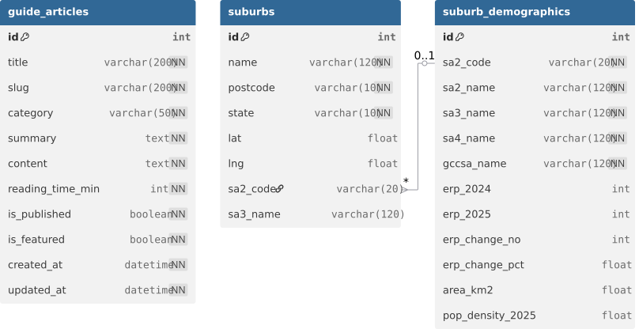

4.1 Where data lives
- Postgres (Neon). Two tables: suburbs and suburb_demographics. Read-only at runtime; written only by offline loaders.
- Repository. Intermediate victoria_population_table.csv under app/data/ for reproducible loads.
- Browser localStorage. Bookmarks only — kept on the user's device, never sent to the server.
- No caching in Iteration 1. SerpApi responses are not persisted; a short-TTL cache is on the backlog if quota or latency warrants it.

4.2 Update frequency and retention
Suburbs reload per iteration (or sooner if locality changes affect the autocomplete). Population reloads when a new ABS release is published, typically at iteration kick-off. Places are live on every request. Loaded data is replaced in place by each load run; SerpApi responses are not retained; localStorage bookmarks persist until the user clears them.

4.3 Security posture
- API keys: SerpApi's key is the only secret; lives in server-side env only, excluded via .gitignore, never logged or sent to the browser.
- Transport: all inbound and outbound calls over HTTPS.
- Inputs: suburb names validated against the suburbs table before being forwarded to SerpApi, preventing arbitrary query injection.
- Errors: short, user-safe messages on upstream failure — no stack traces or third-party envelopes leaked.

5. Data risk register
Rated on combined likelihood and impact. Reviewed at each iteration retrospective alongside the Security Plan.
Risk | Rating | Mitigation
SerpApi quota exhausted during demo or peak use | Medium | User-safe "couldn't load places right now" message with retry; monthly quota monitoring; short-TTL cache on the backlog if needed.
SerpApi key leaked | Low / High impact | Server-side env only; .gitignore excludes .env; never logged or returned; rotation procedure in the Security Plan.
Suburb-to-SA2 mismatch shows wrong population | Medium | Hide the snapshot line for ambiguous suburbs rather than show an approximation; maintain an exclusion list for known edge cases.
Stale population data after a new ABS release | Low | Idempotent load scripts make refresh a ~5-minute task; calendar reminder set for the ABS annual release.
Inaccurate third-party listings (closed venues, wrong hours) | Medium | UI disclaimer invites users to confirm details directly; Minuri does not verify listings; results are for browsing, not bookings.

